Group | Lab. leader | Name | Neptun code | Date

Flow curve measurement
Upsetting – Rastegaev method
Laboratory report

Place: | Machine/max load:  Upper die speed: | Gauge:  Accuracy:

Nominal specimen sizes:
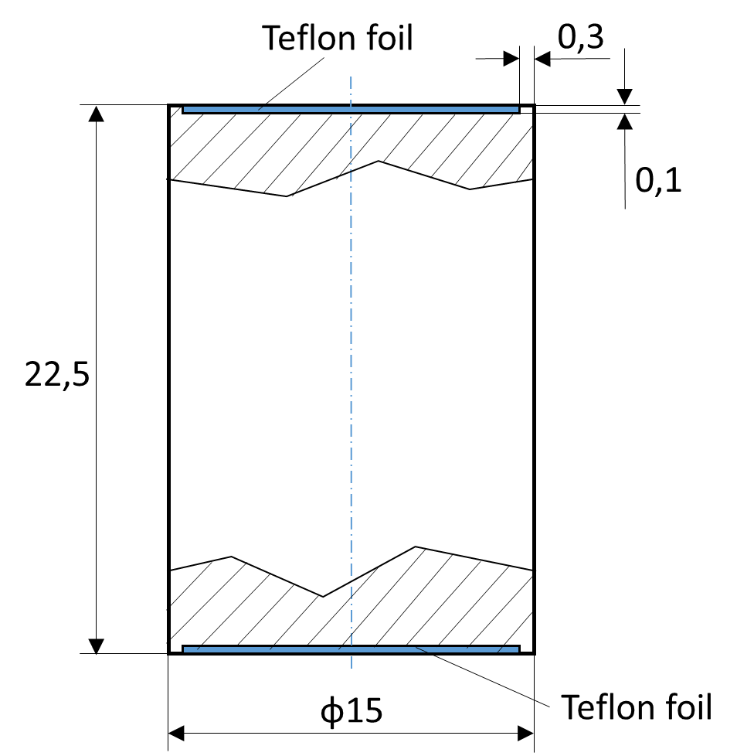 | Test conditions:  - uniaxial stress state  - lubricant is Teflon foil (0.12 mm)  Specimen mark/material:  Measured initial specimen sizes:  h₀ = ……….. mm  d₀ = ……….. mm  Measured quantities:  force . . . . . F  height . . . . h  Specimen cross-section:  A = d² π / 4 or  A₀ h₀ = A h → A = A₀ h₀ / h
Equivalent plastic strain:  $\overline{φ}=ln\left(\frac{h_{0}}{h}\right)$ | Flow stress:  σ _{f} $=\frac{F}{A}=\frac{4F}{d^{2}π}=\frac{F h}{A_{0} h_{0}}$

Nr. | F (kN) | h (mm) | A (mm²) | $\overline{φ}$ (-) | σ _{f} (MPa)
0 | --- |  |  | --- | ---
1
2
3
4
5
6
7

Flow curve

Fit an approximative power function on the measured points (e.g. in Excel).
Make and insert a diagram containing the measured points and the curve of the fitted approximate function (flow stress in MPa versus equivalent plastic strain).
Give the fitted function with its calculated parameters and the value characterizing the quality of the fitting (R²).

Place of diagram

Evaluate the measurement in short.

